______Galliano__________
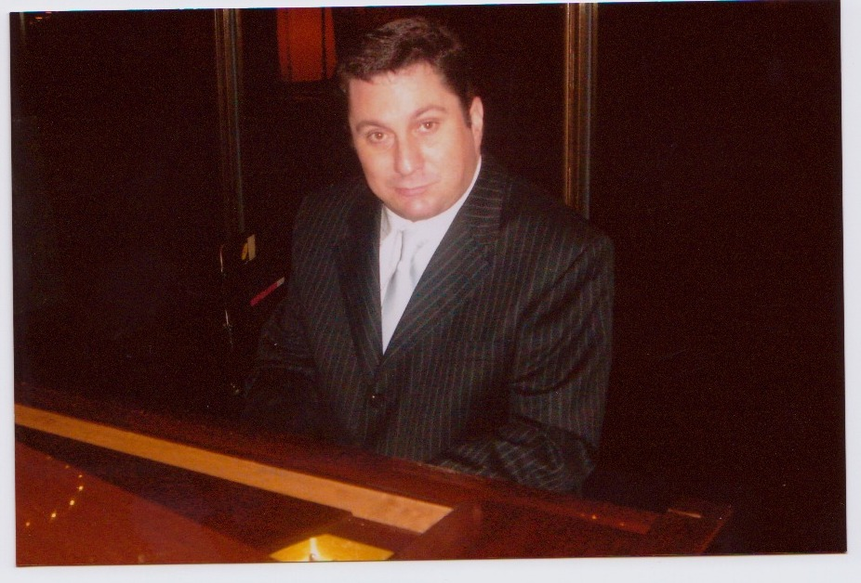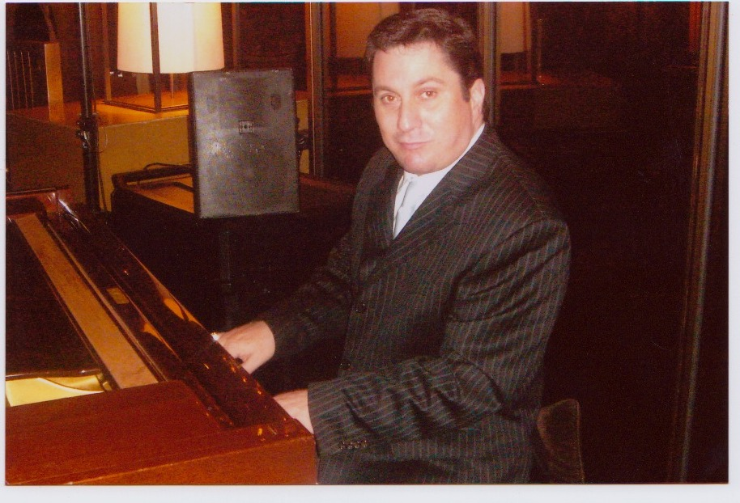

Galliano Sommavilla

Buddy Greco Support act (and other various) Continental Café 1993, 1995
(Including CD Launch 1996, various other supports
and solo performances 1993-1997)
1999 ~ current** Pianist Crown Casino (Atrium bar and JJ’s Bar and Restaurant)
1993 ~ 1999 Resident pianist The Chifley on Flemington
1989 Resident pianist Chateau Commodore Hotel
1988 ~ 1989 Pianist Hyatt on Collins
1985 ~ 1990 Resident pianist Sandringham Hotel
1987 ~ 1989 Resident pianist Sentimental Bloke Hotel
1983 ~ 1985 Resident pianist Skyways International (Zagames)
1982 ~ 1983 Resident pianist Croxton Park Hotel
1974 ~ 1981 Musician Numerous school/other productions

Achievements :

1996 CD Release “Rain in my bathtub” Original/Instrumental
1996 Pianist for Silent Film Festival Original music
1997 ~ 1998 Co~ordinator/Composer Kool school Program

Specialty Cookbook “Playing with Food” (Italian) with original Music CD *currently published (2006)

Childrens Picture and music Book ‘Up the apple tree’ (release 2007/2008)

1995 ~ 1999 Instrumental teacher (piano) Mackillop Regional College, Werribee
1996 ~ 1997 Instrumental teacher (piano) Laverton Secondary College, Laverton
1997 ~ 1998 Instrumental teacher (keyboard) Marian College, Sunshine

Style :

Suitable background music reflecting the style and place of the venue. A varied and extensive repertoire covering a
variety of musical styles, from popular (pop) music, jazz standards, early music, movie scores, (original instrumental),
film noir (mood music) to modern day (current) pop(ular) pieces. An individual style of performance.

(Song list to follow)*****

Song list / assortment (this list is only a guide*****)
Current: (examples of ‘now’)
Pink- nobody knows
Christina Aguilera- hurt, beautiful
Justin Timberlake-what goes round…..
Guy Sebastian-(various)
Dixie Chicks-not ready to make nice
Snow Patrol-chasing cars
Shannon Noll- (various)
The Fray-how to save a life
James Morrison-you give me something
Silverchair-straight lines
Evanescence-Lithium, My immortal
James Blunt-various
Kelly Clarkson-breakaway

Favorite pop: (contemporary/classics)
Various songs by Elton john, Billy Joel, Robbie Williams, The Eagles, Cat Stevens, The Beatles, Coldplay, U2, Bryan Adams, The Bee Gees, Phil Collins, Lionel Richie, Paul Simon, and many, many others

Film (score) music:
Film themes including ‘Cavatina’ from the Deer Hunter, ‘the windmills of your mind’ from the Thomas crown affair, ‘The Farm’ from ‘Road to Perdition’, love theme from ‘Cinema Paradiso’, theme from ‘The man from Snowy River’, ‘Lara’s theme’ from ‘Doctor Zhivago’, theme from ET, many others.
Composers including: John Williams, Maurice Jarre, Ennio Morricone, Thomas Newman, James Horner, David Foster, John Barry, Bruce Roland,
Burt Bacharach, Henry Mancini, Vangelis, Marvin Hamlisch, Lalo Schifrin.

Various selection of Jazz standards, performers including Frank Sinatra, Dean Martin, Tony Bennett, Perry Como, Andy Williams, Cole Porter, Duke Ellington, Louis Armstrong, Michael Buble.

Various selections of songs from Musicals including; Cats, Evita, The Phantom of the Opera, Les miserables, Sound of Music, Chess, My Fair Lady

Various Australian including: John Farnham, Ross Wilson, Jet, Missy Higgins, Delta Goodrem, Air Supply, Pete Murray, Cold Chisel, Little River Band, Peter Allen, Neil Finn (Split Enz), Savage Garden, Kylie Minogue, Tina Arena and many others.

Miscellaneous: Television themes (theme from M.A.S.H., theme from Cheers, theme from Prisoner, etc), Football songs, Anthems, jingles, wedding songs

(slightly) Left of centre songs: Artists including: Tori Amos, Pink Floyd, Tom Waits, David Gray.

Various Classical/ and other (genres): Examples may include ‘Claire de Lune’ –Debussy, Fur Elise-Beethoven and various others

